1. **Literature Survey:**

**Journal - IEEE**

|  |  |  |  |
| --- | --- | --- | --- |
| **Year** | **Authors** | **Paper Title** | **Inference** |
| 2023 | Rachel L. Hybart and Daniel P. Ferris, Senior Member IEEE | Embodiment for Robotic Lower-Limb Exoskeletons: A Narrative Review | Research on embodiment of objects external to the human body has revealed important information  about how the human nervous system interacts with robotic  lower limb exoskeletons. |
| 2023 | Rhys Newbury, Morris Gu, Lachlan Chumbley, Arsalan Mousavian, Clemens Eppner | Deep Learning Approaches to Grasp Synthesis: A Review | Grasping is the process of picking up an object by applying forces and torques at a set of contacts. Recent advances in deep-learning methods have allowed rapid progress in robotic object grasping. |
| 2023 | Bahareh Ahkami , Graduate Student Member, IEEE, Kirstin Ahmed , Alexander Thesleff , | Electromyography-Based Control of Lower Limb  Prostheses: A Systematic Review | In the studies that were investigated, large variations were found between the control methodologies, type  of research participant, recording protocols, assessments, and  prosthetic hardware. |
| 2023 | Maria Koskinopoulou, Zhuoqi Cheng, Member, IEEE, Alperen Acemoglu,  Darwin G. Caldwell, Fellow, and Leonardo S. Mattos. | Robotic Devices for Assisted and Autonomous  Intravenous Access | This paper will review these recent technical developments, including  methods and systems for vein imaging and localization, needle  insertion, venipuncture detection, catheter placement, and complete  robotic IVA platforms. |
| 2023 | Filip Gasparic; Nikola Jorgovanovic; Christian Hofer; Michael F. Russold; Mario Koppe | A Novel Sensory Feedback Approach to Facilitate Both Predictive and Corrective Control of Grasping Force in Myoelectric Prostheses | Reliable force control is especially important when using myoelectric upper-limb prostheses as the force defines whether an object will be firmly grasped, damaged, or dropped. |
| 2023 | Kyujin Hyeon; Chongyoung Chung; Jihyeong Ma; Ki-Uk Kyung | Lightweight and Flexible Prosthetic Wrist With Shape Memory Alloy (SMA)-Based Artificial Muscle and Elliptic Rolling Joint | This letter proposes a novel prosthetic wrist that emulates the anatomical structure of the human wrist, specifically the wrist bones and muscles responsible for wrist movements. To achieve a range of motion (ROM) and load-bearing capacity comparable to the human wrist joint. |
| 2022 | Revanth Damerla, Kevin Rice, Daniel Rubio-Ejchel, Maurice Miro, Enrico Braucher, Juliet Foote, Issam Bourai | Design and Testing of a Novel, High-Performance Two DoF Prosthetic Wrist | This review determines that no existing prosthetic wrist meets the target specifications due to the presence of actuators and transmissions that do not offer sufficient torque density, power density, and specific power. |
| 2021 | Gaoyang Pang , Graduate Student Member, IEEE, Geng Yang , Member, IEEE,  and Zhibo Pang , Senior Member, | Review of Robot Skin: A Potential Enabler for Safe  Collaboration, Immersive Teleoperation, and  Affective Interaction of Future Collaborative Robots | This review introduces the potential applications of cobots for human care together with those demanded features. In addition, the explicit roles of robot skin in satisfying the escalating demands of those features  on inherent safety, sensory feedback, natural interaction, and energy autonomy are analyzed. |
| 2021 | Rani Kolaghassi, Mohamad Kenan Alhares, and Konstantions Sirlatzis | Systematic Review of Intelligent Algorithms in Gait Analysis and Prediction for Lower Limb Robotic Systems | This review paper systematically explores the current use  of intelligent algorithms in gait analysis for robotic control, especially the control of active lower limb exoskeletons and orthoses. |
| 2020 | David Pinto-Fernandez, Diego Torricelli, Member, IEEE, Maria del Carmen Sanchez-Villamanan,  Felix Aller, Katja Mombaur | Performance Evaluation of Lower Limb  Exoskeletons: A Systematic Review | This review aims to organize this information, and identify the most promising performance indicators that can be converted into practical benchmarks. We focus our analysis on lower limb functions, including a wide spectrum of motor skills and performance indicators. |

**Journal - ScienceDirect**

|  |  |  |  |
| --- | --- | --- | --- |
| **Year** | **Authors** | **Paper Title** | **Inference** |
| 2023 | Jinliang Zhu, Yuanxi Sun, Jie Xiong, Yiyang Liu, Jia Zheng, Long Bai. | Design and experiment of a variable stiffness prosthetic knee joint using parallel elastic actuation | This paper proposed an active prosthetic knee joint with a unique variable stiffness parallel elastic actuation (VSPEA) mechanism. The VSPEA prosthetic knee joint is implemented by a geared five-bar mechanism with a motor-screw system. |
| 2023 | Alexander Hopkins, Rodney Ho, Derrick Varner | Becoming Whole Again: How Prosthetics Shape the Human Experience | • Discuss the history of prosthetics.  • Explore how prosthetics became a necessity.  • Describe the psychological impact of limb, eye loss, and replacement.  • Look forward to the future of prosthetic use. |
| 2023 | Ingy S. Soliman, Mohamed Sherine El-Attar, Mohamed Fata, Kareem mohamed kheneifar, Amal Ashry | A novel design for prosthetic ear guiding device: A technical not | This article describes a newly designed Prosthetic Auricular Guide (PAG) that allows for accurate planning and positioning of both the auricular implants and the prosthetic auricle. |
| 2023 | Sheila Clemens, Corey Pew | A pilot study comparing prosthetic to sound limb gait mechanics during a turning task in people with transtibial amputation | This descriptive study offers the first phase-specific quantification of turning biomechanics in people with lower limb amputation. Results indicate that people with unilateral transtibial amputation spend more time on and experience higher impulses through their sound compared to their prosthetic limb during 90° turns. |
| 2023 | Sahand C. Eftekari, Lucas Sears, Steven P. Moura, Sydney Garelick, D’Andrea T. Donnelly | A framework for understanding prosthetic embodiment for the plastic surgeon | In this review, assess the current literature on prosthetic embodiment to explore the main mechanisms of embodiment and how each allows a prosthesis to interface with the human body. In doing so, we provide a comprehensive, holistic framework for understanding this concept. |
| 2023 | Sitan Huang, Rachel H. Teater, Karl E. Zelik, Kirsty A. McDonald | Biomechanical effects of an articulating prosthetic toe joint during stair navigation for individuals with unilateral, below-knee limb loss | In this study, we aimed to assess the user preferences and biomechanical effects of a flexible prosthetic toe joint during stair ascent and descent for persons with unilateral lower-limb loss. Nine participants with unilateral lower-limb loss were recruited |
| 2022 | Panagiotis Filis, Dimitrios Varvarousis, Georgios Ntritsos, Dimitrios Dimopoulos, Nikolaos Filis, Nikolaos | Prosthetic reconstruction following resection of lower extremity bone neoplasms: A systematic review and meta-analysis | • Prosthetics are the mainstay in surgery after resection of extremity bone tumors.  • For these patients gait parameters deteriorated compared to healthy individuals.  • Further refinement of surgical techniques is required.  • New rehabilitation strategies and follow-up programming are needed. |
| 2022 | Justine Jihyun Kim, Jinseok Kim, Jongsu Lee, Jungwoo Shin | Influence of lifestyle pattern on preference for prosthetic hands: Understanding the development pathway for 3D-printed prostheses | this study identifies the heterogeneous preference of potential users of 3D-printed prosthetic hands with regards to their daily lifestyle patterns using discrete choice experiment and latent class analysis. The results indicate that the consumers of prosthetic hands have varying group-wise preferences for different types of prosthetics based on their lifestyle patterns. |
| 2022 | Hrushikesh Sayar, Jayant Karajagikar, Sojwal Deshmukh | Prosthetic limb arm for armless human | This paper serves humanity where we are trying to assist the people who have lost their hands or arms due to accident or warfare. To create a full-functioning arm so that this armless person could do their daily tasks easily and efficiently. |
| 2022 | Francesca Vincitorio, Guido Staffa, Oskar C. Aszmann, Maurizio Fontana, Rickard Brånemark, Pericle Randi, Thomas Macchiavelli, Andrea G. Cutti. | Targeted Muscle Reinnervation and Osseointegration for Pain Relief and Prosthetic Arm Control in a Woman with Bilateral Proximal Upper Limb Amputation | The report has demonstrated that the potential effects of TMR can be expanded by the use of an OPI, which makes the prosthetic harness unnecessary and preserves the full range of motion of the shoulder. To improve the intuitive control of the prosthetic arm and for neuroma and phantom pain management. |

**Journal - Elsevier**

|  |  |  |  |
| --- | --- | --- | --- |
| **Year** | **Authors** | **Paper Title** | **Inference** |
| 2023 | Jinliang Zhu a, Yuanxi Sun a, Jie Xiong a, Yiyang Liu a, Jia Zheng b, Long Bai a | Design and experiment of a variable stiffness prosthetic knee joint using parallel elastic actuation | This paper proposed an active prosthetic knee joint with a unique variable stiffness parallel elastic actuation (VSPEA) mechanism. The VSPEA prosthetic knee joint is implemented by a geared five-bar mechanism with a motor-screw system. |
| 2023 | Manish Kumar, Krishnanand, A. Varshney, Mohammad Taufik. | Hand prosthetics fabrication using additive manufacturing | This study aims to critically compare the designs, 3D printing methods and materials used for hand prosthetics. the study shows that fused filament fabrication has been widely used to fabricate hand prosthetics using the material such as – polylactic acid (PLA), acrylonitrile butadiene (ABS) and thermoplastic polyurethane (TPU). |
| 2023 | Wen Xu MD, MS, Yoshiko Toyoda, Ines C. Lin. | Upper Extremity Prosthetics: Current Options and Future Innovations | The goal of this article was to describe the current options that exist for upper extremity prosthetics and explore the recent advances and future directions in prosthetic technology and surgical techniques. |
| 2023 | Daniel C. Norvell PhD, Wayne T. Biggs CPO, Jeffrey Bott, Alison W. Henderson PhD, Kathryn P. Moore | The Development and Validation of a Novel Prosthetic Component Sophistication Classification System | This study aims to develop a lower limb prosthesis (LLP) sophistication classification system that categorizes prosthetic component prescriptions into “basic,” “intermediate,” and “advanced” and assess its content validity, reliability, and accuracy. |
| 2023 | Jeffrey Klott, Tyler J. Brolin | Diagnostic Evaluation of Prosthetic Joint Infections of the Shoulder | • Total number of shoulder joint replacement is increasing, so number of infections will also rise.  • Cutibacterium acnes is the most common pathogen in shoulder prosthetic joint infection  • Diagnostic workup for shoulder PJI is more nuanced than total hip and knee evaluation. |
| 2023 | Mridul Bansal, Aryan Mehta, David X. Zhao, Saraschandra Vallabhajosyula | Valve-in-valve transcatheter mitral valve replacement procedure in prosthetic valve stenosis | A patient presented with acute respiratory failure and shock due to severe prosthetic mitral valve stenosis. A valve-in-valve transcatheter mitral valve replacement procedure was performed via the transeptal approach due to his high-risk presentation with good results. |
| 2023 | Nicholas F. Cozzarelli, Irfan A. Khan, Nareena Imam, Gregg R. Klein, Harlan Levine, Ari Seidenstein, Musa B. Zaid, Jess H. Lonner. | Robotic-Assisted Total Knee Arthroplasty Has Similar Rates of Prosthetic Noise Generation as Conventional Total Knee Arthroplasty | Noise has been reported to occur with relatively high frequency after conventional total knee arthroplasty (C-TKA), and this may impact the incidence of patient satisfaction and function. The purpose of this study was to compare the rate of patient-reported prosthetic noise generation after robotically-assisted TKA (RA-TKA) and C-TKA. |
| 2023 | A. Tarsitano, F. Ceccariglia, M. Bevini, L. Breschi, P. Felice, C. Marchetti | Prosthetically guided mandibular reconstruction using a fibula free flap: three-dimensional Bologna plate, an alternative to the double-barrel technique | The aim of this study was to present a new design for a patient-specific three-dimensionally printed reconstructive plate (3DBO-PSI) that positions the fibula bone at the height of the resected mandibular alveolar bone while restoring the mandibular profile to ensure a correct morphological outcome. |
| 2022 | Julian Matias Freue, Claudio Norberto Enciso, Reinaldo Manuel Campestri | Spontaneous Prosthetic Fracture in a Patient with Relapsed Multiple Myeloma | The latter scenario usually has a dismal prognosis. Bone fractures are frequent in patients with multiple myeloma (MM), sometimes requiring a surgical approach. Eventually, plasmacytomas can also develop surrounding a synthetic prothesis. |
| 2018 | Koksal Gundogdu a, Sumeyye Bayrakdar b, Ibrahim Yucedag | Developing and modeling of voice control system for prosthetic robot arm in medical systems | The developed control system has been applied on four-jointed robot arm. As a result of the tests; it has been observed that the technique utilized in our system achieves about 11% more efficient voice recognition than currently used techniques in the literature |

1. **Photos of JSS Hospital**

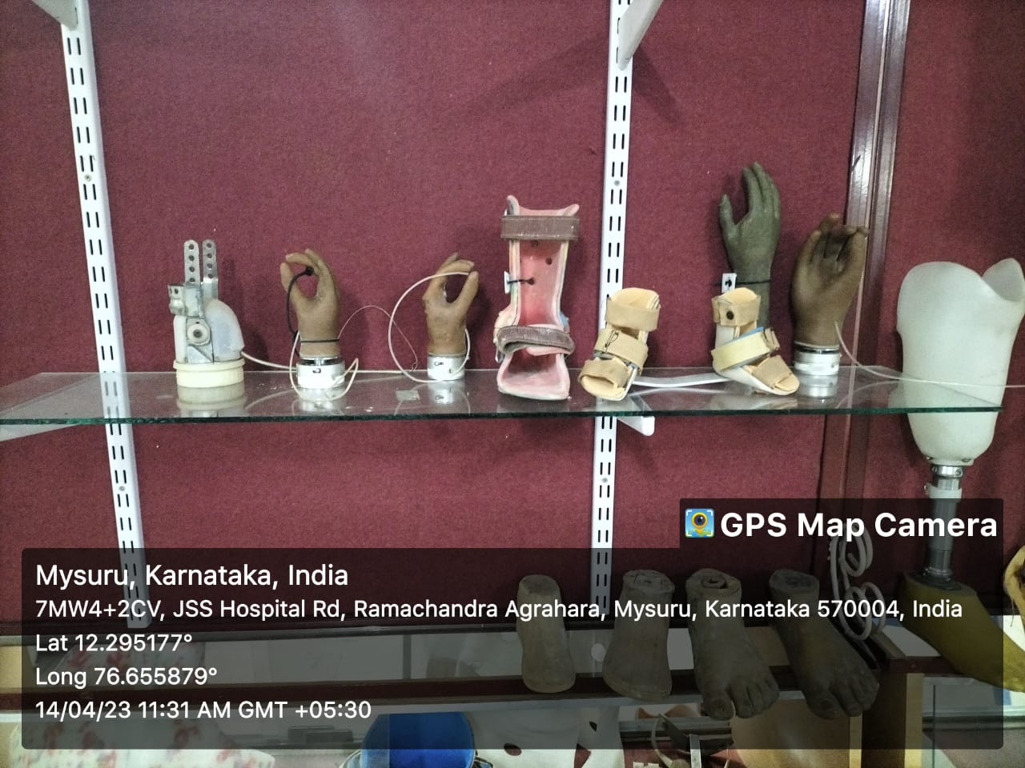

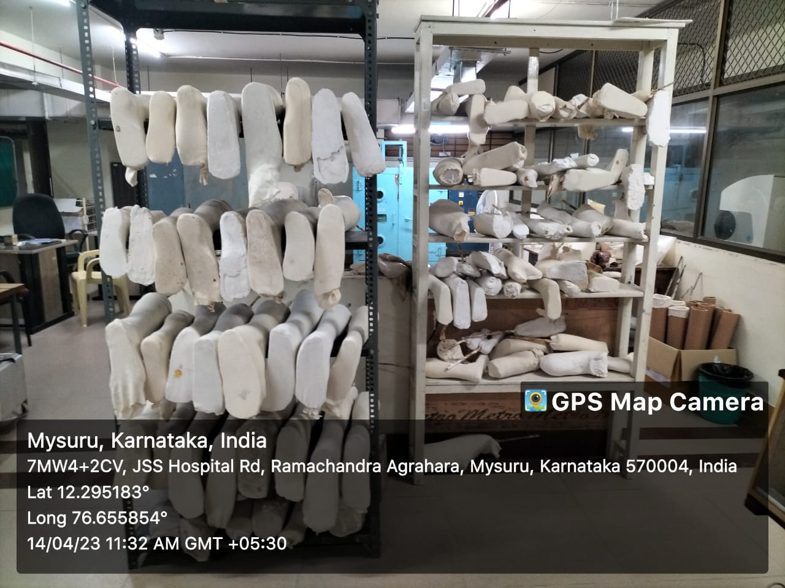

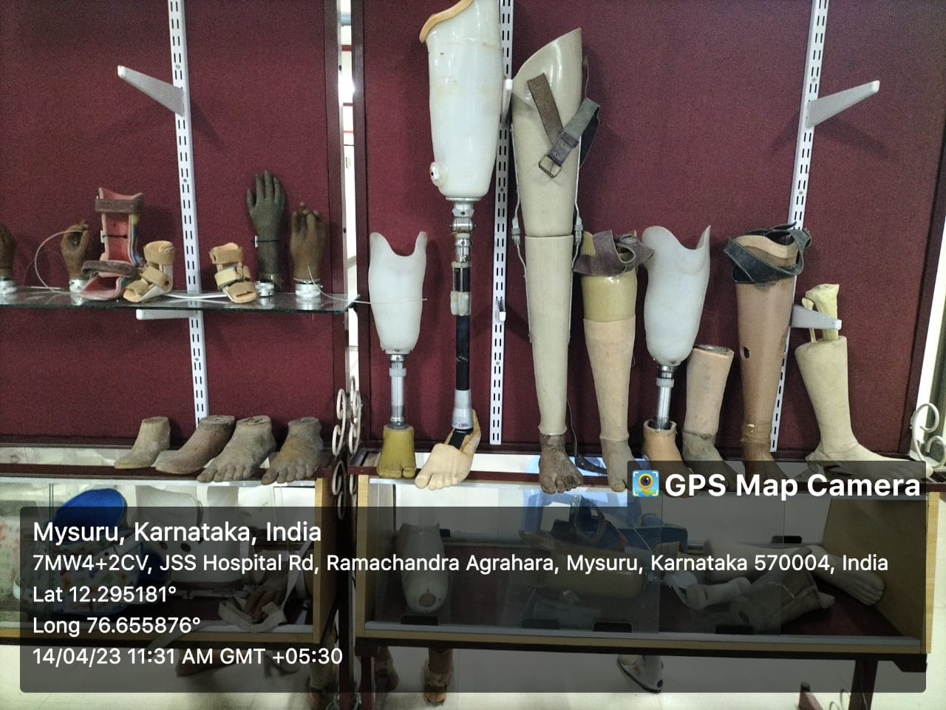

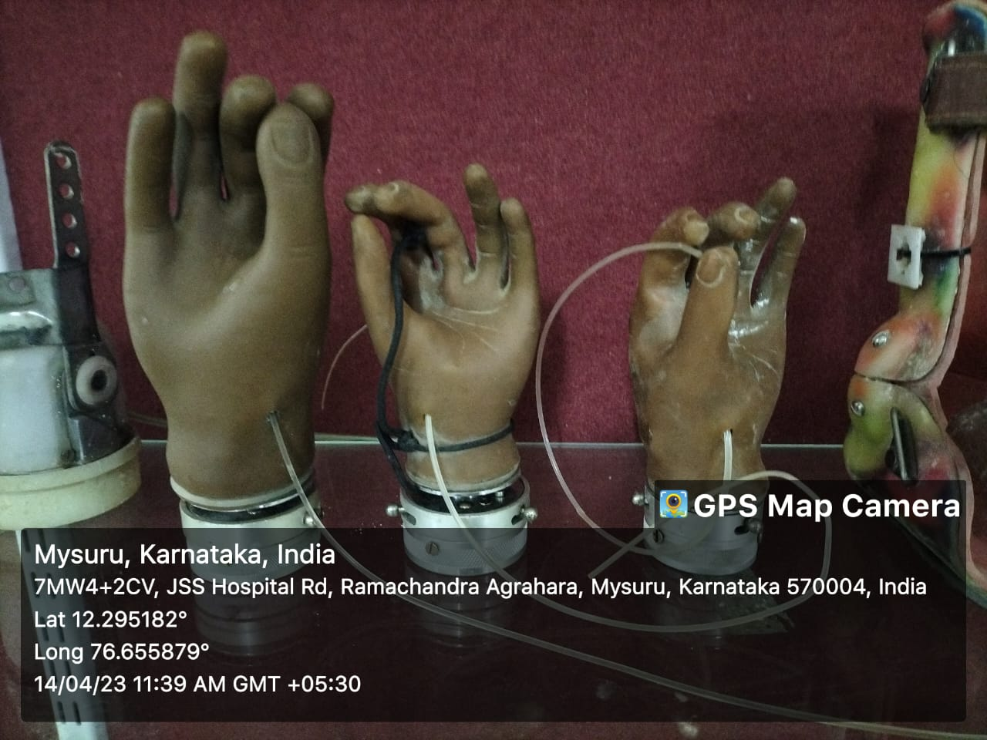

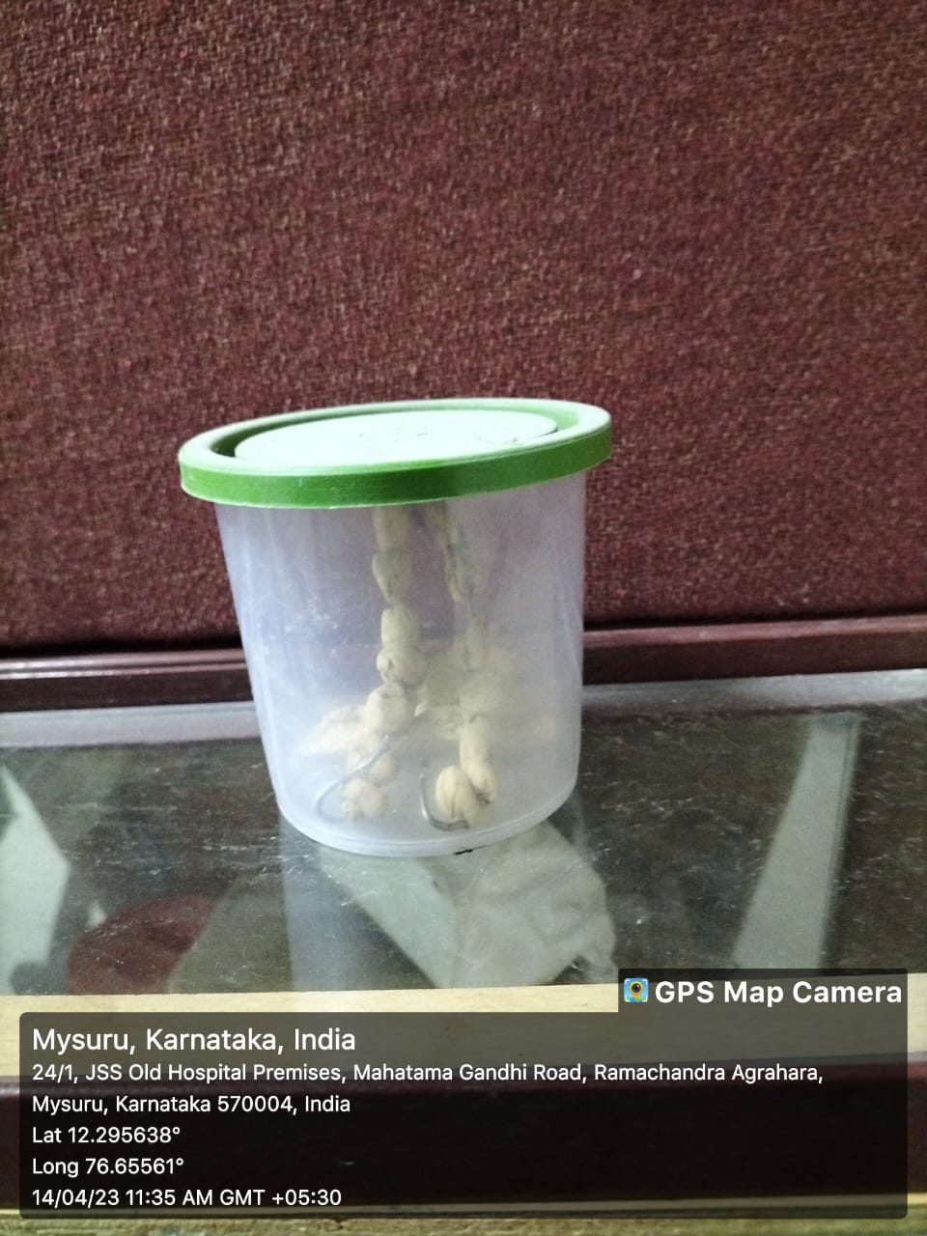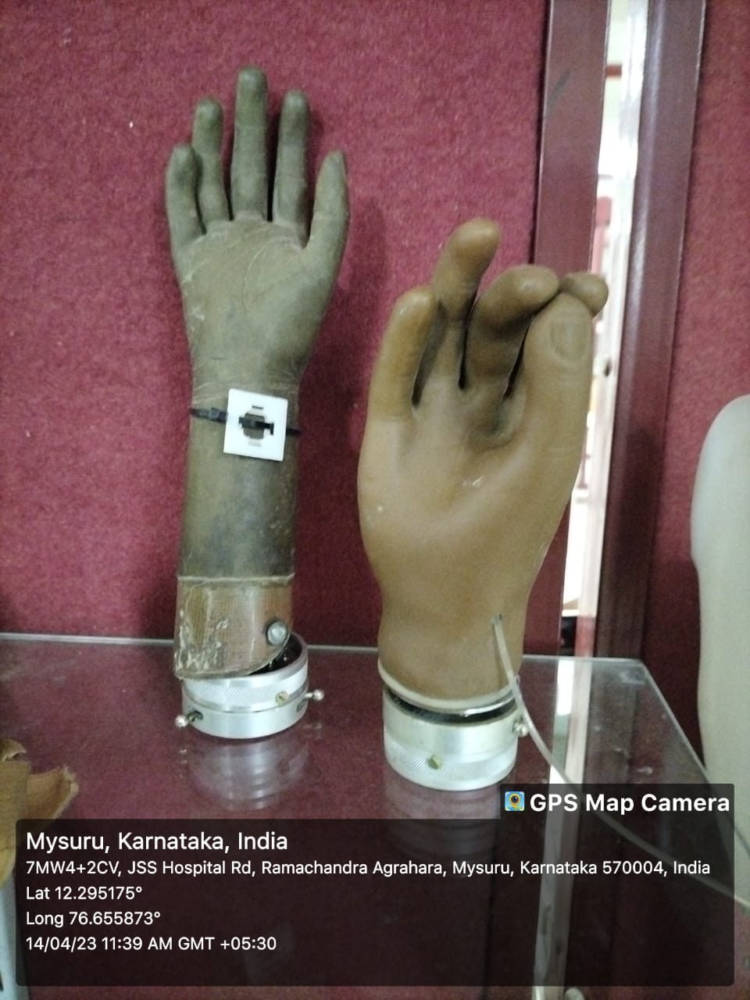

1. **COMSOL**

* Open COMSOL version 5.6 application and then select Model Wizard



* Select 3D in Space dimension

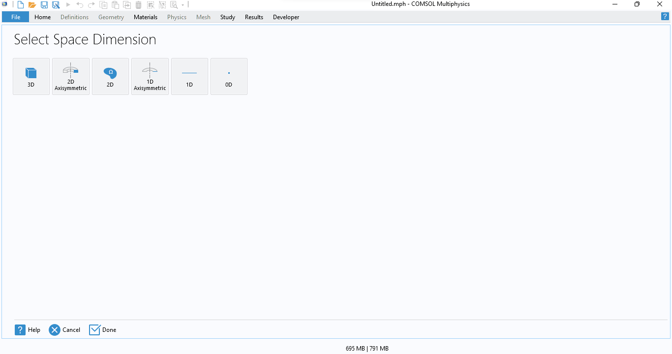

* Double click on “Heat transfer in solids” in physics and click on study



* Click on Stationary study and click on done

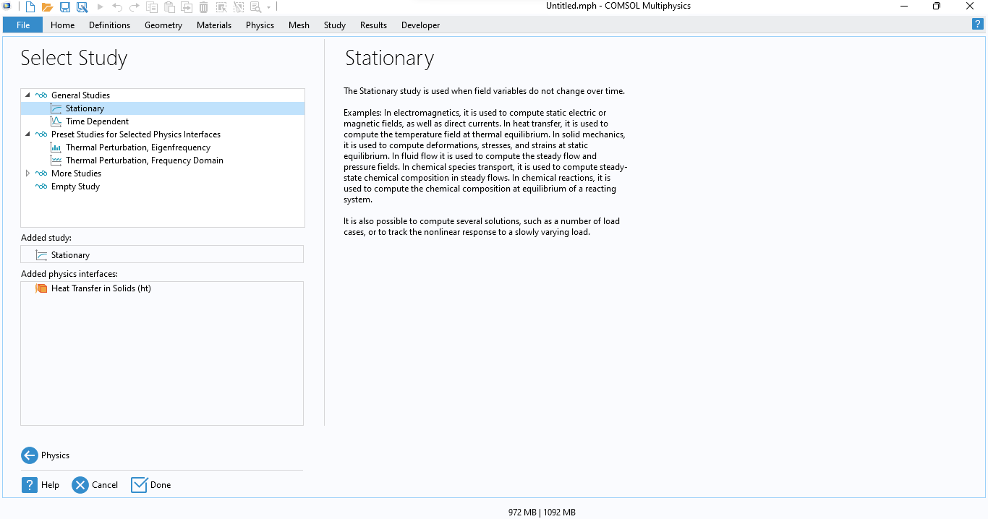

* Right click on Geometry and select “import”. Under file name select the “browse” and select the 3D file and the click on “import”.

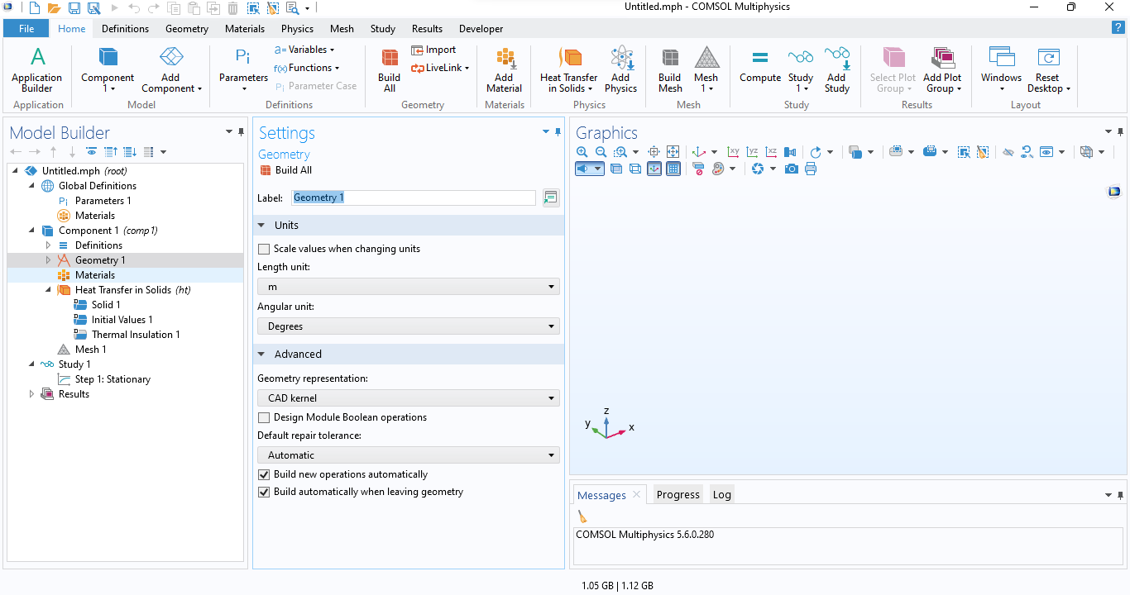

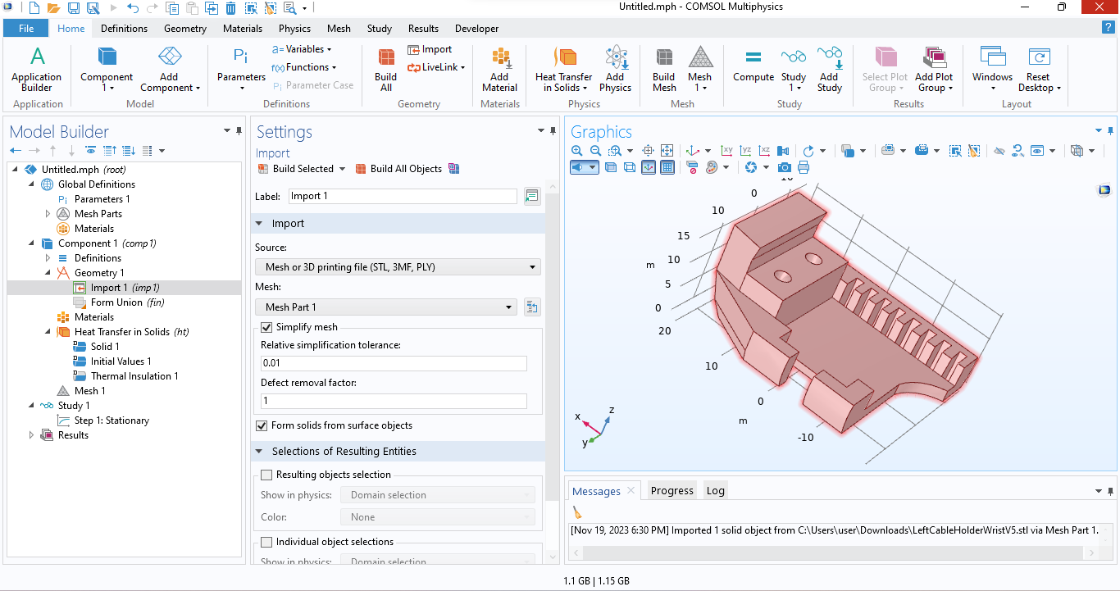

* After import, right click on “materials” and select “add material from library”. Search for plastic and double click on “Acrylic Plastic”

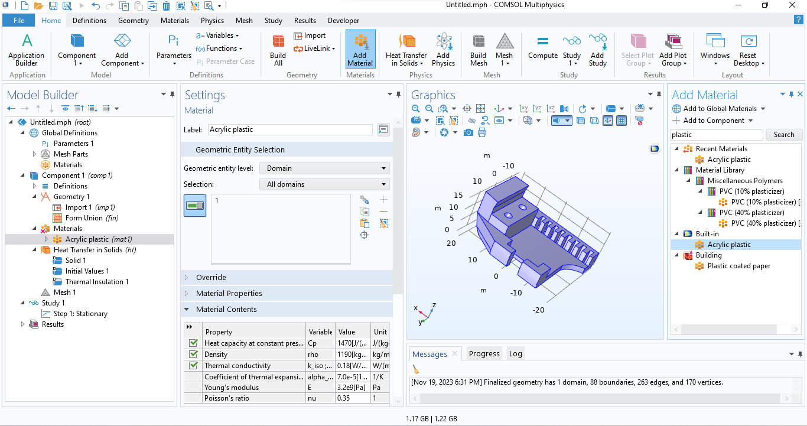

* Right click on “Heat transfer in solids” and select “Temperature”. Define temperature as 353.15K and select the part where the maximum temperature reaches. Similarly also select for minimum temperature of 303.15

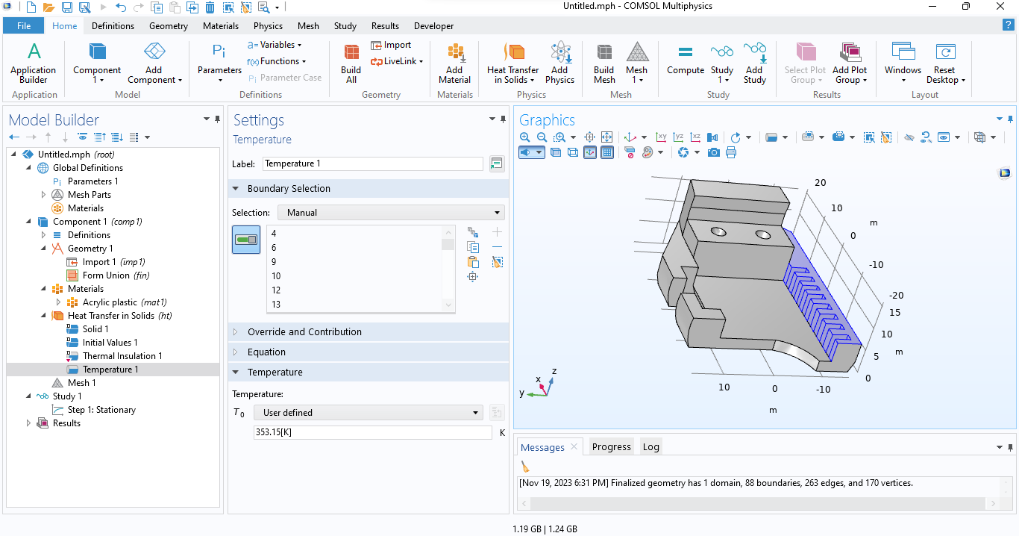

* Select “Mesh” and click on “Build All”

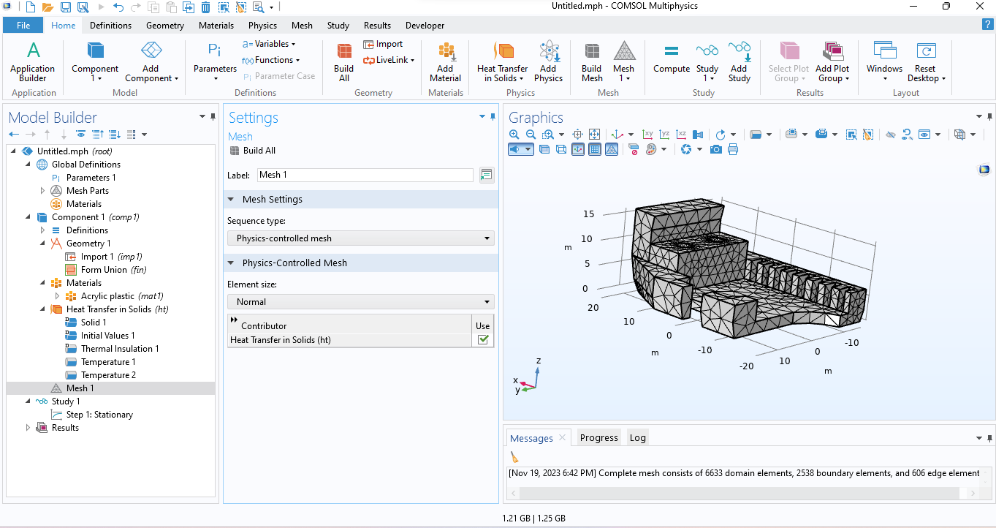

* Select “Study 1” and then click on “Compute”

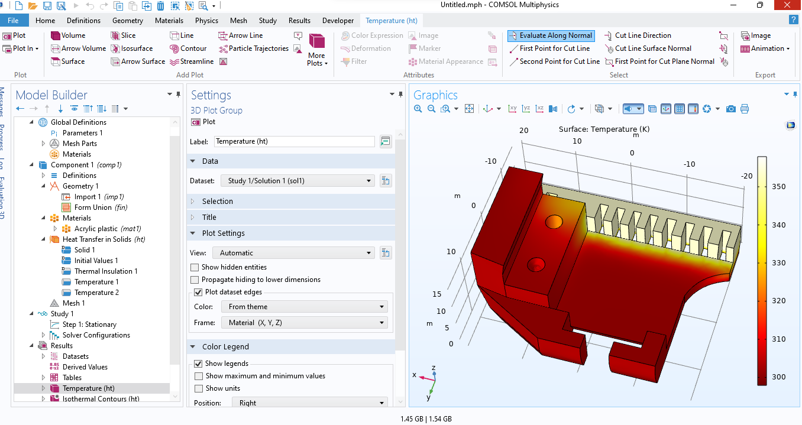

1. **Bio amp Suite**

* Open “Arduino IDE” and upload the basic code, the code is available in “Upside down lab”. Code link: <https://github.com/upsidedownlabs/Muscle-BioAmp-Candy>

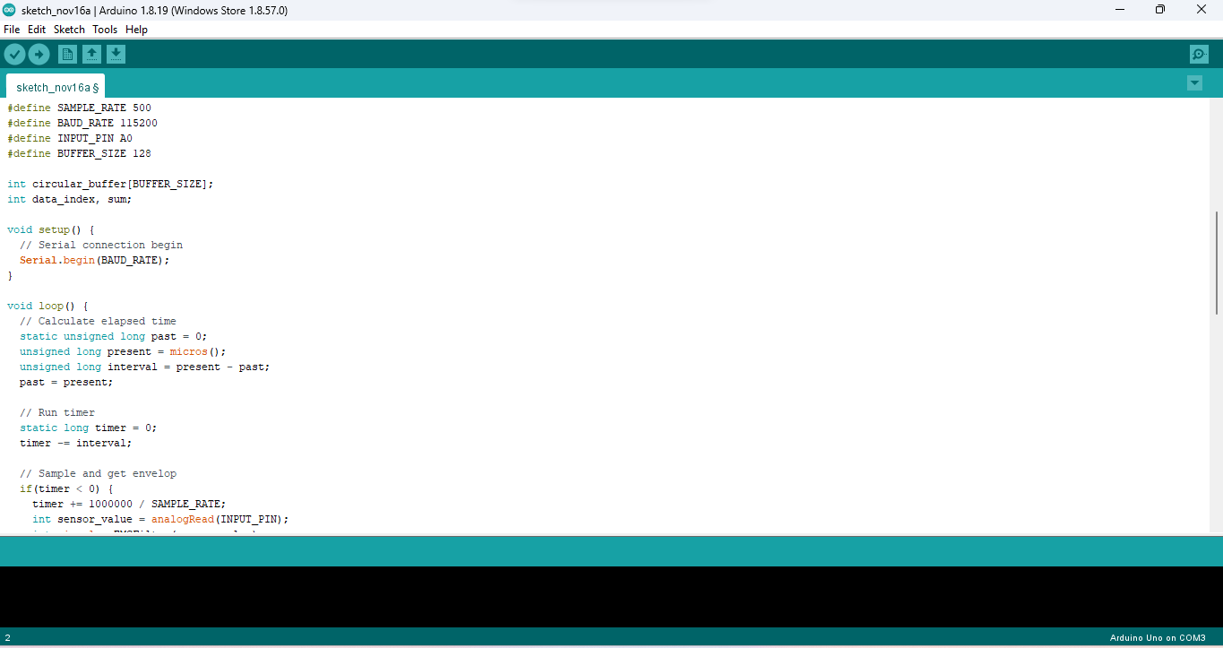

* Upload the code to Arduino board and connect A0 pin to output of Bio-amp suite and after uploading the open serial plot from tool bar

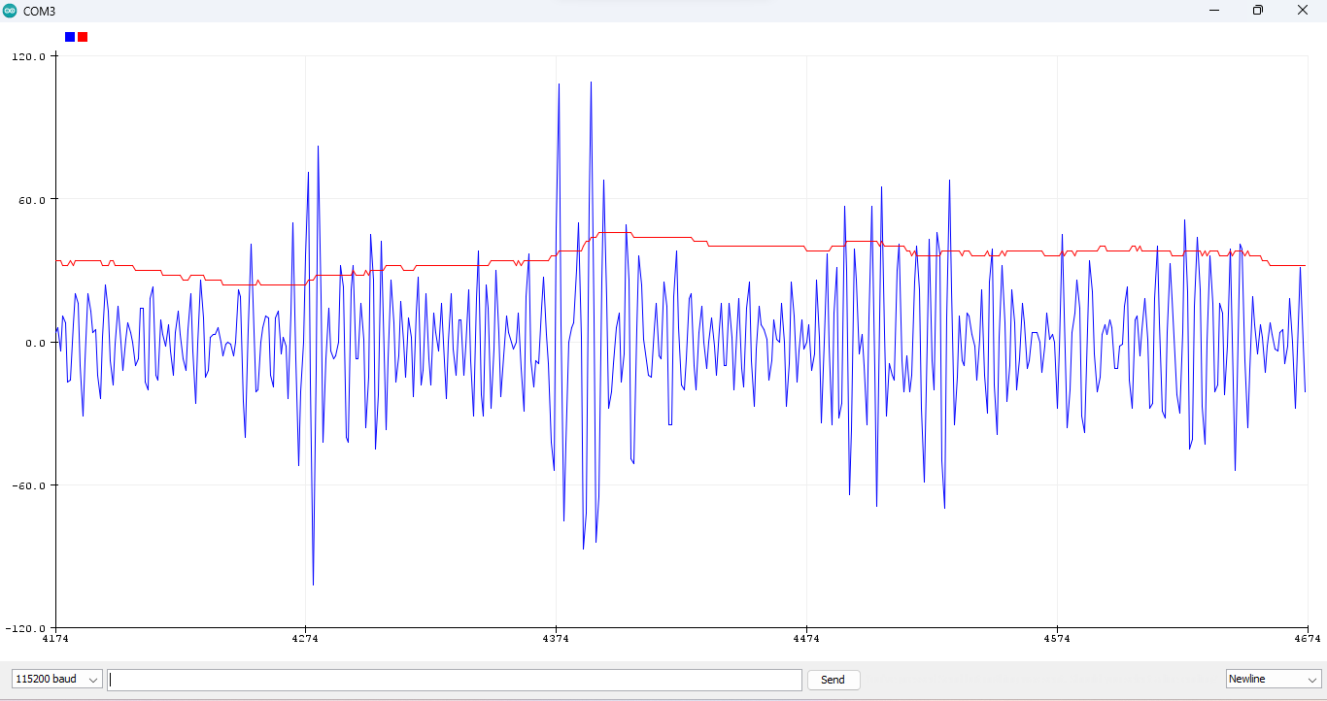

* Higher peak value indicate the open hand and lower peak value indicate the closed hand